Please note that the bridges shown in this photo were designed and constructed under a different set of rules and were tested with a different loading device. Therefore, structures similar to those pictured here may not satisfy the requirements specified herein.
 | 

2026 Popsicle Stick Bridge Contest
Overview | Eligibility
The Richmond Branch of the American Society of Civil Engineers (ASCE) is pleased to sponsor the 2026 Popsicle Stick Bridge Contest on Sunday, March 15, 2026. Students will design and build their own bridges out of popsicle sticks and will compete for several awards. The competition will be held at:  Dewey Gottwald Center at the Science Museum of Virginia  2301 W. Leigh St., Richmond, VA  11:30 am to 3 pm (Competition starts at 12:30 pm) | The competition is open to all greater Richmond area Middle School students (grades 6th-8th) and High School students (grades 9th-12th). Students may submit entries as individuals, or as a Team. Team sizes will be limited to three (3) students per team.  Students do not need to be from the same school or in the same age group to be on a team together; however, any team consisting of both middle and high school students will have to compete in the high school division.

Registration | Competition
All students interested in competing should complete the registration form online at:  www.ascerichmond.org.  The deadline for all team registrations is February 20, 2026. The competition is limited to 100 submissions. If this limit is reached before the registration deadline, any additional students wishing to register will be placed on a waiting list. Please direct any questions to:  Travis Miller, EIT.  Koontz Bryant Johnson Williams  Email: tmiller@kbjwgroup.com | The competition takes place during the Richmond Joint Engineers Council’s “Celebrating Engineering Ingenuity Day” which will include a variety of STEM-based activities by different Richmond area engineering societies.  Team check-in will start at 11:30 am on 3/15/25, and the award ceremony for the event will occur after the testing portion of the competition. Teams will bring their completed bridge to the announced location at the specified time to be inspected. After the inspection is complete, testing will begin.  Admission to the competition and the other Celebrating Engineering Ingenuity Day events, which are all in the Dewey Gottwald Center, will be free for everyone. The Science Museum is providing participants and one chaperone free admission to the Science Museum on CEI Day. Please use the Dewey Gottwald main entrance at 2301 W. Leigh Street when attending CEI Day.
Awards
The following awards will be given separately to both Middle and High School Divisions:  - Highest Efficiency Rating:  $100 and Certificate  - Second Highest Efficiency Rating:  $50 and Certificate  - Third Highest Efficiency Rating:  $25 and Certificate | Both divisions will compete together for the following awards:  - Most Aesthetically-Pleasing Bridge*:  $75 and Certificate  - Innovation Contest**:  $75 and Certificate
All participants will receive a Certificate of Participation
* A team of judges will evaluate each bridge before load-testing.
**Optional – See below for details on the Innovation Contest.

Please note that the bridge shown in this photo was designed and constructed under a different set of rules and was tested with a different loading device. Therefore, the structure pictured here may not satisfy the requirements specified herein.
General Competition Requirements
- Objective: To span a clear distance of 19 inches using a bridge constructed of only standard, craft- variety popsicle sticks and Elmer’s glue. Each bridge will be scored in accordance with an Efficiency Rating (ER), which will be calculated by the following equation:
$$ER=L+\frac{L}{W}$$
where:
L = Load to failure (lbs.)
W= Weight of structure (lbs.)

- Maximum Weight of Bridge = 450 g (about 1 pound, or approximately 250 sticks plus glue)
Minimum Length of Bridge = 21 inches (any portion of the bridge below the supports must not be longer than 18½ inches). Please note that the bridge must be designed to rest on top of the two supports, which measure 4½ inches by 1 ½ inches. Bearing against the front, rear or sides of the supports will not be allowed. Refer to the drawings for more information.
- Required Sticks: Standard, 4½” x ³/8” x ¹/12” craft-type Popsicle sticks (readily available at all craft and department stores).
- Required Glue: Elmer’s ® Glue-All Multi-Purpose Glue or equivalent.
- This is the white, craft variety of glue. Bridges using any other glue such as wood glue, super glue, epoxy, or any other type of adhesive will be disqualified).
- The bridge must be able to accommodate a 5”x5” loading plate resting on top of the structure and a ½ inch diameter threaded rod extending through the center of the bridge for testing. Please refer to the drawings.
- Popsicle sticks are limited to a glued ½” overlap (maximum) at all connections. Open gaps are allowed between adjacent sticks.
- Similar to last year, bridges will be loaded from the top of the structure, not at the roadway surface using a 5”x5” loading plate connected to the tester using a ½” diameter threaded rod that freely extends through the center of the bridge. All bridges must be able to accommodate this rod and loading plate (refer to the figures and photos shown on the following pages).
- Bridges must meet the additional requirements shown on the following pages for connection and geometric limitations.
- Disqualification: Bridges not meeting the requirements listed in these rules will be subject to disqualification. Disqualified bridges will still be eligible for the innovation or aesthetic awards but will not be considered for the efficiency score awards. Disqualified bridges will be tested until failure as long as it remains safe to do so. The decision of the judges at the time of the event is final.
**Note: Students and teachers may submit requests for information (RFI) to clarify the rules via email, but all RFIs must be submitted BEFORE 5 pm EST on Sunday, March 8th, 2026. RFIs submitted after this time will not be reviewed.
Helpful Hints
- Sticks can be cut, sanded, trimmed or colored with colored pencils but all sticks must be visible to inspection and may not be painted or stained in any way. Sticks cannot be coated with glue so as to laminate them either.
- The glued connection between the sticks is most likely the weakest link in the bridge so be sure to allow at least 24 hours before the competition for the glue to dry.

- Note that the score is influenced by the weight of the bridge. Try to maximize the strength of the bridge while keeping the weight as low as possible.

Additional Requirements
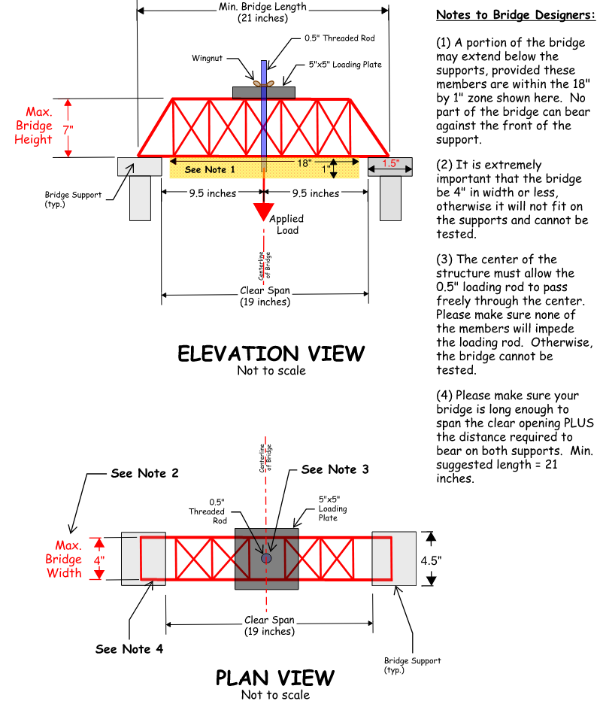

Additional Requirements Cont.
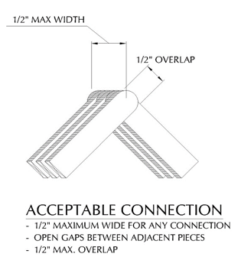
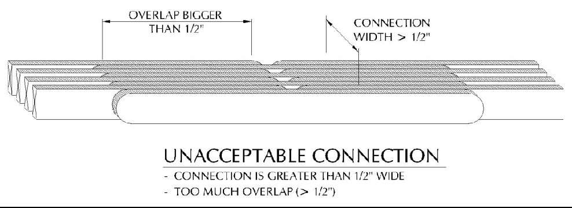

Please note that the bridge shown in this photo was designed and constructed under a different set of rules and was tested with a different loading device. Therefore, the structure pictured here may not satisfy the requirements specified herein.

Additional Information

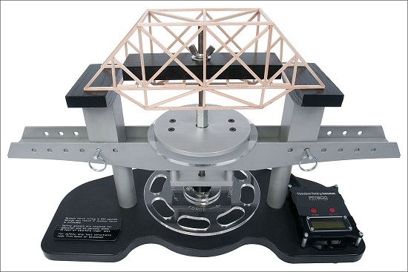

BRIDGE TESTING APPARATUS
(Note how bridge will be supported. Required clear span of 19 inches not depicted in photograph. Also, the loading block will be positioned on top of the structure, as shown below, NOT within it, as shown above.)

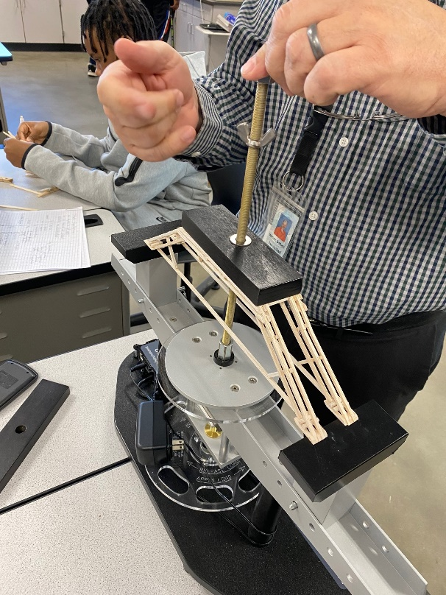

PROPER POSITION OF LOADING PLATE
(Note how loading plate will be applied at the top of the bridge with a 1/2” diameter steel rod passing through the center of bridge. All bridges must be able to accommodate this rod. For load plate dimensions, please see additional drawings.)

Innovation Contest
Each team can choose to enter their bridge into a separate Innovation Contest ($100 prize). Each team wishing to take part in the Innovation Contest can explain the innovation behind their design in a typed report and turn this in on the day of the event. The report should be a maximum of 2 pages with one additional page for sketches. Sketches or drawings may be helpful and are encouraged to be used. Some suggestions for items to address in the report are:
- What strategies or concepts did you use when designing your bridge? Did you do supplemental research to learn these concepts? If so, which resources? (Research is encouraged!)
- Where along the bridge do you think your bridge will break and why?
- What challenges did you encounter while designing and constructing your bridge? How did you overcome them?
- If you participated in the contest before, what changes did you make to this year’s design and why? How do you think this loading apparatus changes the requirements for the bridge design?
- If you were allowed to use any other materials besides Elmer’s glue and popsicle sticks, which would you choose?

Frequently Asked Questions:
Please note that the bridge shown in this photo was designed and constructed under a different set of rules and was tested with a different loading device. Therefore, the structure pictured here may not satisfy the requirements specified herein.

- Question: Why is the maximum width of bridge 4” if the standard popsicle sticks come in 4.5”? Is the standard this year to cut all the popsicle sticks?

  - Response: The width of the supports is 4.5”, so the width of the bridge must be narrower than that, which is why we are limiting the bridge width to 4” this year (to make sure they fit on the testing apparatus). Since we have removed the requirement to have a continuous road surface (deck) from previous years, it’s not required that the sticks be cut to accommodate a 4” bridge width.

- Question: Note 1 to bridge designers (in “Additional Requirements”) states that the bridge can’t “bear” against the front of the support. Does that mean underneath the bridge the supports can’t touch the equipment at all? Prior to 2024, bridges used to be able to have supports that could touch the underneath section for additional stability.

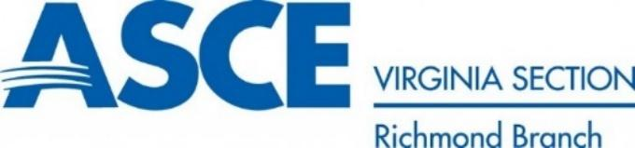
  - Response: Correct, no parts of the bridge hanging below the deck may bear against the equipment.

